Drawing Energy Flow Diagrams

**What to do:**

Spread around the room are activities which demonstrate energy transformations. Complete the activities by following the steps below. Answer the questions as you go.

**Activity 1**

1. Gently tap the forked end of the tuning fork on the table.
2. 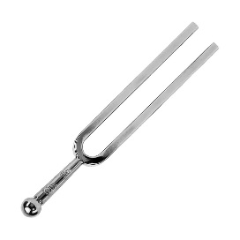What do you notice happens?

**Activity 2**

1. Wind up the toys. What type of energy are you using to do this?
2. ****How is that energy stored in the toys before you let them go?  
   (Hint: what else doesn’t move until you release it?)

**Activity 3**

1. Turn on the torch.
2. What type of energy is stored in the battery?
3. What is the final energy produced by the torch?
4. What energy is produced in between?

**Activity 4**

1. Set up a ramp so that the top end is 10 cm above the ground.
2. Place the car at the top of the ramp.
3. Allow the car to roll down the ramp and along the floor.
4. How far did the car roll?
5. Where did the energy for the car to move come from?
6. How could you increase this energy?

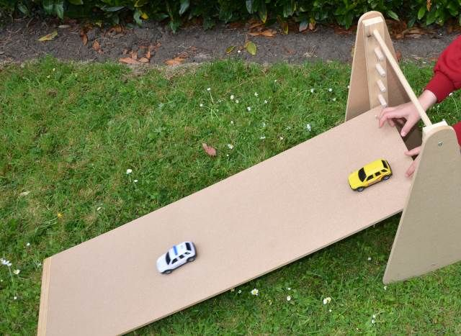

**Activity 5**

1. Place the solar panel in the sunlight and turn the switch on. What starts to happen?
2. 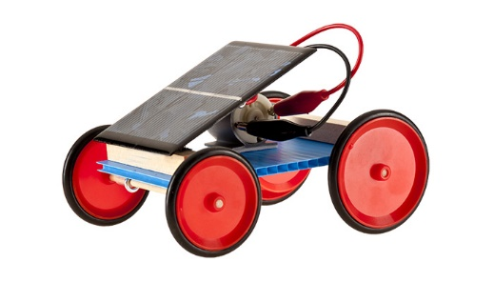Leave the motor running for a minute, then pick it up. What has happened?

**RESULTS**

Complete the table by identifying the input energy forms, output energy forms, and any intermediate (in-between) energy forms for each activity.

|  |  |  |  |
| --- | --- | --- | --- |
| **Activity** | **Input Energy** | **Intermediate Energy** | **Output Energy** |
| 1 |  | N/A |  |
| 2 |  |  |  |
| 3 |  |  |  |
| 4 |  |  |  |
| 5 |  |  |  |

**QUESTIONS**

Draw an energy flow diagram for each activity.

1.

2.

3.

4.

5.